First question from data request: 1. Does atypical perceptual processing track with reduced cognitive and social functioning? 2. Which social and cognitive functioning variables best predict atypical task performance? 3. Does accounting for cognitive/social functioning significantly reduce group differences?

So atypical perception is: 1. Ebbinghaus -> context_sensitivity, misleading_index, helpful_index (don’t know what 2sd is yet) 2. Mooney -> Silverstein’s paper from 2021 seems largely focused on upright_percent_reported and inverted_percent_reported

Cognitive functioning is: 1. the Wide Range Achievement Test (WRAT) -> wrat_standardscore 2. the Brief Assessment of Cognition in Schizophrenia-Symbol Coding (BACS) -> bacs_total 3. Hopkins Verbal Learning Test-Revised (HVLT-R) -> hvlt

Social functioning is Global Functioning Scale: 1. Social and Role (GFS-S/R) -> gfs_current, gfr_current 2. Social Phobia Scale ->sps_total

so let’s load data

library(data.table)  
main_dir = "/Users/victorpokorny/Library/CloudStorage/GoogleDrive-vpokorny123@gmail.com/My Drive/CAPR Ebbinghaus and Mooney/"  
load(paste0(main_dir,'RData/fixed_upright_faces_data.RData'))  
source(paste0(main_dir,'R_scripts/funcs.R')) # big group of functions

let’s look at hists and scatterplots of key variables starting with Ebbinghaus

hist(main_df$helpful_index)

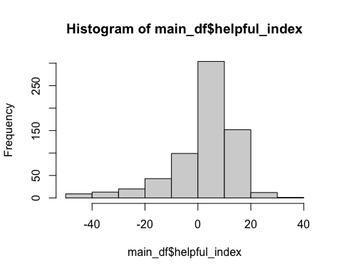

hist(main_df$misleading_index)

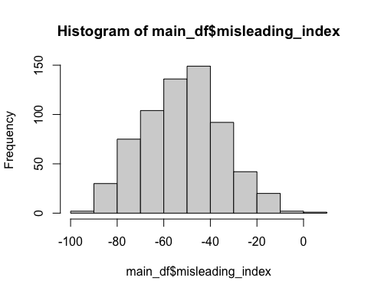

hist(main_df$context_sensitivity)

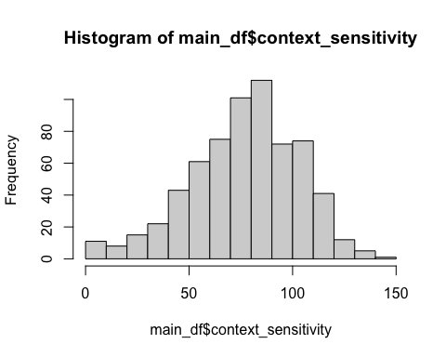

scatterplot(main_df$context_sensitivity, main_df$helpful_index)

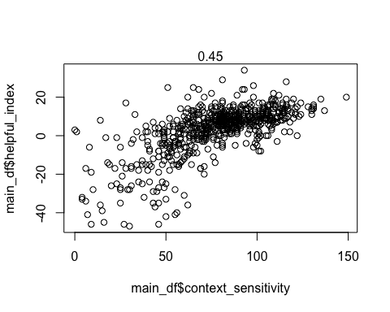

scatterplot(main_df$context_sensitivity, main_df$misleading_index)

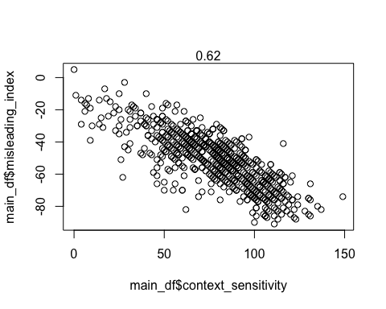

scatterplot(main_df$helpful_index, main_df$misleading_index)

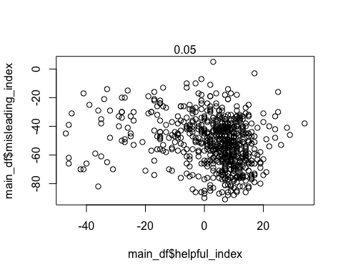

#ok so helpful and misleading aren't strongly correlated with each other, but both are   
#strongly correlate with the difference score (which makes sense)

next let’s look at Mooney

hist(main_df$upright_faces_reported)

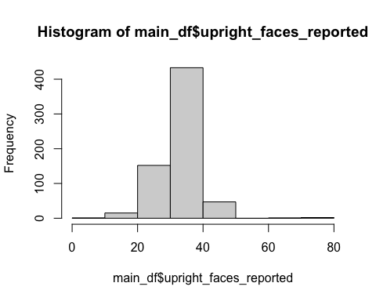

hist(main_df$inverted_faces_reported)

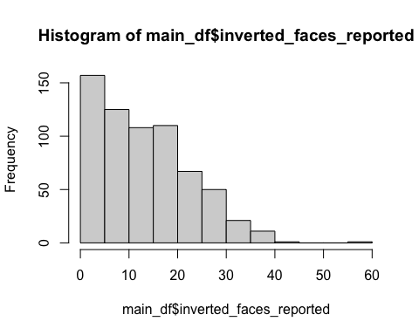

sum(!is.na(main_df$inverted_faces_reported))

## [1] 651

sum(!is.na(main_df$upright_faces_reported))

## [1] 651

#shouldn't there be a max of 43 responses?  
#let's get rid of folks with more than 43 upright or inverted responses  
main_df$upright_faces_reported[main_df$upright_faces_reported>43] <- NA  
main_df$inverted_faces_reported[main_df$inverted_faces_reported>43] <- NA  
hist(main_df$upright_faces_reported)

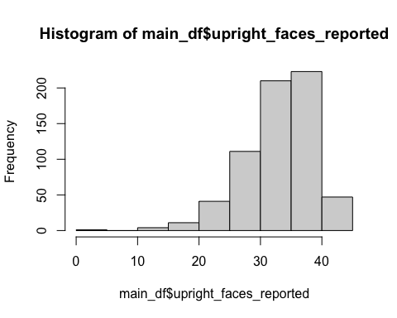

hist(main_df$upright_percent_reported)

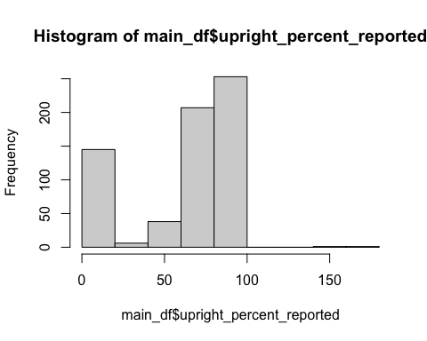

hist(main_df$upright_percent_reported_adjusted)

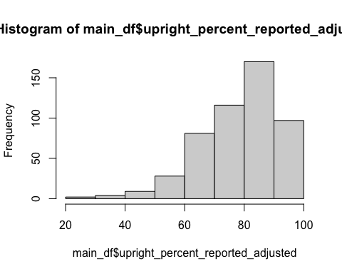

hist(main_df$inverted_faces_reported)

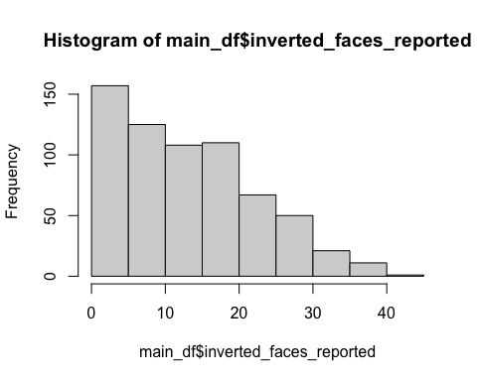

#phew so hopefully we've sufficiently cleaned these data  
scatterplot(main_df$upright_faces_reported,main_df$inverted_faces_reported)

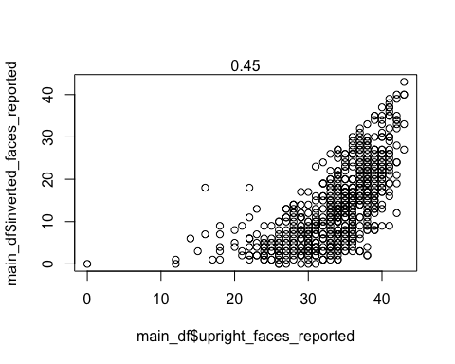 now let’s look at social variables…

hist(main_df$gfr_current) # ceiling effect here as well

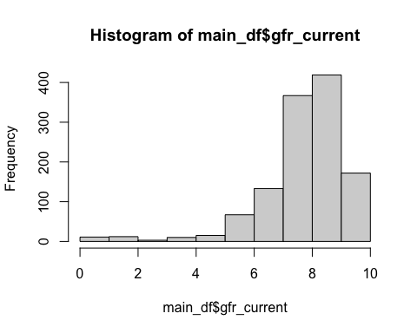

hist(main_df$gfs_current) # bit of a ceiling effect here it would seem

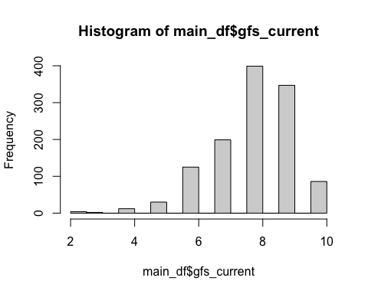

scatterplot(main_df$gfr_current,main_df$gfs_current ) #apparent range restriction here

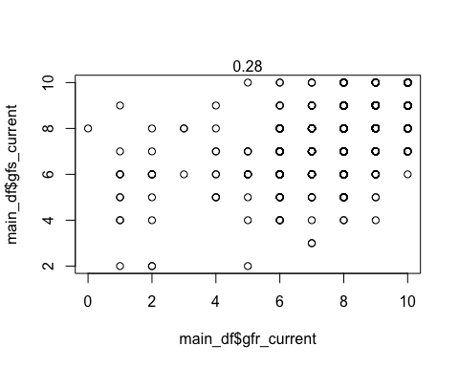

#how about sps... very ugly  
hist(main_df$sps_total)

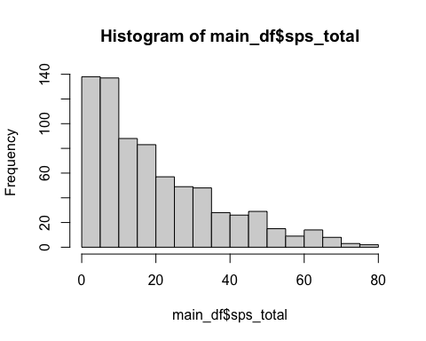

#looks quite a bit better!   
scatterplot(main_df$sps_total,main_df$gfs_current)

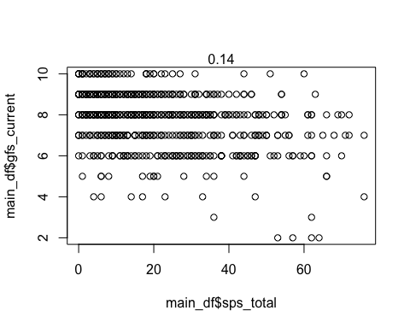

#log transform doesn't change correlation much

now let’s look at cog variables

hist(main_df$wrat_standardscore) #looks fine

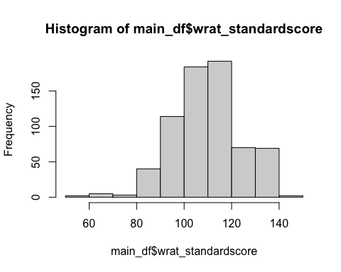

hist(main_df$bacs_total) #looks fine

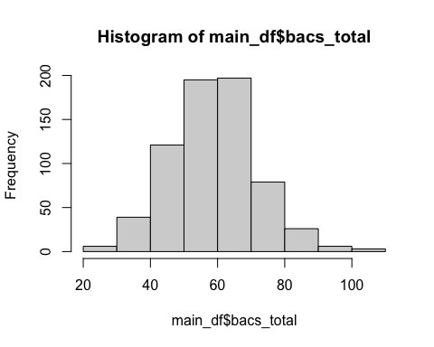

hist(main_df$hvlt_total_score) #seems fine for now

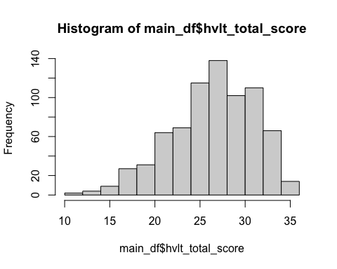

scatterplot(main_df$wrat_standardscore, main_df$bacs_total) #wow very little association

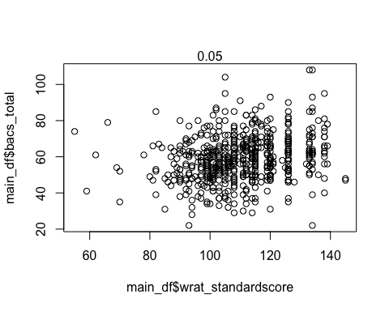

scatterplot(main_df$hvlt_total_score, main_df$bacs_total) #better

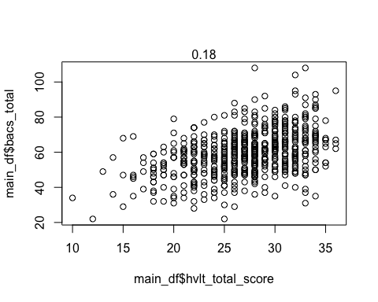

scatterplot(main_df$hvlt_total_score, main_df$wrat_standardscore) #not great

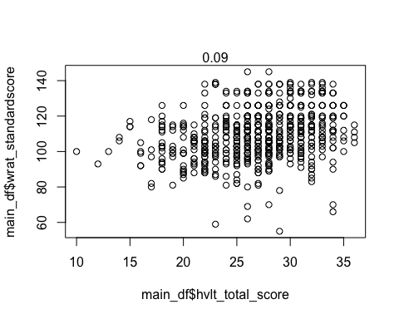

Finally we need to do a bit of recoding of some variables

main_df$help_index = main_df$helpful_index #something weird about this variable label  
main_df$phenotype_final<-ifelse(main_df$phenotype=="hsc",  
 ifelse(main_df$p1_sev>1 |   
 main_df$p2_sev>1 |   
 main_df$p3_sev>1 |  
 main_df$p4_sev>1 |   
 main_df$p5_sev>1,  
 "hsc_sub","hsc_other"),main_df$phenotype)  
  
main_df$phenotype <- as.factor(main_df$phenotype)  
main_df$phenotype_final <- factor(main_df$phenotype_final,   
 levels = c('hc','hsc_other','hsc_sub','chr') )  
#we want only baseline values   
main_df <- main_df[main_df$visit == 'bl',]  
  
#there is a weird duplicate so let's drop for now  
main_df<-main_df[!duplicated(main_df$src_subject_id),]  
  
#let's also drop folks with NA for their phenotype_final (probably due to having NAs on SIPS)  
main_df<-main_df[!is.na(main_df$phenotype_final)]  
  
#let's make biological sex numeric and make it zeros and ones  
main_df$demo_biological_sex <- as.numeric(main_df$demo_biological_sex)-1  
  
#get rid of folks with negative context sensitivity  
main_df$context_sensitivity <- ifelse(main_df$context_sensitivity<0 |   
 is.na(main_df$context_sensitivity),  
 NA,  
 main_df$context_sensitivity)  
  
  
  
#let's also make some plotworthy variable names  
main_df$`BACS Total`<-main_df$bacs_total  
main_df$`WRAT Standard`<-main_df$wrat_standardscore  
main_df$`HVLT Total`<-main_df$hvlt_total_score  
main_df$`Global Functioning: Role`<-main_df$gfr_current  
main_df$`Global Functioning: Social`<-main_df$gfs_current  
main_df$`Social Phobia Scale`<-main_df$sps_total  
main_df$`Context Sensitivity`<-main_df$context_sensitivity_all_trials  
main_df$`Misleading Index`<-main_df$misleading_index  
main_df$`Inverted Faces Reported`<-main_df$inverted_faces_reported  
main_df$`Upright Faces Reported`<-main_df$upright_faces_reported

let’s save out df and create new script since this one is getting long

#let's save as .RData file to keep meta-data  
save(main_df,file = paste0(main_dir,'RData/cleaned.RData'))